COVER PAGE
Table of Contents

----------
Thanks/Acknowledgements

Summary//Resumé
- goal
- method(s) overview
- Main finding

Intro
High-Performance Supercomputers (HPSCs)* play a critical role in advancing scientific discovery, enabling complex simulations ranging from climate modeling to artificial intelligence training. As computational demands rise, so has the energy required to power these machines. Yet it seems almost contradictory to build and use these systems to address energy use and the carbon impact of electricity without a working knowledge of their own environmental footprint.
Introduced in 1993, the Top500 and Green500 lists offer key perspectives on the increasing use of HPSCs through their biannual rankings—Top500 based on raw computational performance (in FLOPS), and Green500 based on energy efficiency (in FLOPS per Watt). However, performance and energy metrics tell only part of the story.
This discussion belongs in the broader context of digital sustainability. Jevons paradox, which concerns the growth of our use of technology, can help to contextualize the limitations of efficiency rankings as it suggests that improvements in the efficiency of a technology are often accompanied by increased usage of that technology [1]. As supercomputers become more powerful and efficient, their use is likely to expand—calling into question the net environmental benefits, especially when considering fabrication, maintenance, and electricity sourcing.
Currently, there exist open-source tools which aim to help researchers assess and reduce the environmental impact of their computational work. These tools include GreenAlgorithms, which estimates the operational carbon of a given computational task and provides contextual comparisons—such as equivalent air travel or tree sequestration time. The tool emphasizing how factors like geography and system architecture affect results and can be run along with the task in HPSCs at run time [3]. Similarly, Carbontracker focuses on runtime emissions though specifically on Deep Learning (DL) and aims to allow users to predict energy consumption and carbon emissions during model training to enable early intervention and promote energy-aware development practices[4]. This exploration of data, too, focuses on operational carbon of high performance computing systems, but it seeks to visualize trends in carbon impact over time by a large number of systems rather than the impact of one particular. These tools and this analysis do not take into account the full life cycle impact of systems as is accomplished by Machine Learning Life Cycle Assessment (MLCA) tool implemented by BoaviztAPI [5] which extends environmental evaluation to include impacts from the production phase—particularly the manufacturing of GPUs—and estimates abiotic natural resource depletion though, again, of only a particular system.
Recent top-tier systems illustrate the complexity of this issue. For example, El Capitan, housed at Lawrence Livermore National Laboratory in California, leads the Top500 and ranks 26th on the Green500 list as of June 2025 [2]. Its carbon impact, however, is shaped by California’s electricity mix, which includes both renewable energies and fossil fuels. By contrast, ROMEO-2025, ranked No. 2 on the Green500 and located in France’s Champagne-Ardenne region, benefits from the country’s predominantly low-carbon nuclear and renewable energy mix. While El Capitan shows that immense computational power can coexist with high energy efficiency, it also underscores a deeper question: not just how efficiently energy is used—but what kind of energy is used.
A supercomputer powered by renewable energies may have a significantly different carbon footprint than one of equal efficiency relying on fossil-based grids. This paper presents an exploration of the data currently available on HPSCs with regard to their operational carbon impact and mounting energy use. In it, we seek to create datasets to address how much energy HPSCs consume over their lifetime, how to estimate their carbon impact and lifespan, and what errors or uncertainties are present in the current public data. The analyses here build upon previous work by Benhari et. al. looking at energy consumption by systems in the Top500 [6] and rely on data made available by Top500, Boavizta, Ember, and ElectricityMaps.

1. Jevons paradox https://doi.org/10.1016/j.ecocom.2007.02.008
2. https://top500.org/news/el-capitan-retains-top-spot-65th-top500-list-exascale-era-expands/
3. Green Algorithms: Quantifying the Carbon Footprint of Computation- https://advanced.onlinelibrary.wiley.com/doi/full/10.1002/advs.202100707
4. https://github.com/lfwa/carbontracker
5. https://github.com/Boavizta/boaviztapi/blob/main/README.md
6. https://hal.science/hal-04519645
* (Make footnote) While the systems ranked on the TOP500 and Green500 lists are widely considered High-Performance Supercomputers (HPSCs), it's important to note that their rankings are based solely on performance in the Linpack benchmark, which evaluates the ability to solve dense systems of linear equations. As such, the term 'HPSC' is used here to refer to systems recognized for their peak computational potential, though not necessarily optimized for all workloads

2. Methodology
2.1 Data Collection and Preprocessing
2.1.1 Data sources
Datasets used in this analysis come from the Top500 and Green500 lists, Ember, ElectricityMaps, Boavizta, as well as chip data gathered from Intel, AMD, NVIDIA, and TechPowerUp.

Top500
First compiled in Mannheim, Germany in 1993, Top500 publishes a semiannual ranking of the 500 most powerful high performance computing (HPC) systems worldwide. The ranking is based on results from the High-Performance Linpack benchmark provided by Top500 in which the system solves a dense system of linear equations and reports the number of floating point operations per second (FLOPS). FLOPS do not capture all aspects of HPC performance and, as such, cannot address the overall performance of the system, the Linpack benchmark remains a standard due to its scalability and applicability across a wide range of architectures, including recent exascale systems.

Green500 https://web.archive.org/web/20160620115925/http://www.top500.org/green500/
The Green500 ranking was introduced in 2007 as a compliment to the Top500 to emphasize power efficiency amid the rise of performance-at-any-cost computing which saw the construction of systems needing large cooling facilities for the vast amount of heat produced. In 2016, the Green500 list became part of the Top500 project.

Ember: Monthly Electricity Data https://storage.googleapis.com/emb-prod-bkt-publicdata/public-downloads/ember_electricity_data_methodology.pdf
Ember is a global energy think tank with datasets on electricity generation, emissions, net imports, and demand. Ember collects and harmonizes data from national and international entities. The Monthly Electricity dataset used in this analysis contains generation and impact data from 85 geographies fills in gaps using ARIMA models.

ElectricityMaps https://github.com/electricitymaps https://portal.electricitymaps.com/datasets
ElectricityMaps is an open-source platform with electricity generation and flows with a granularity as fine as 5-minute intervals. ElectricityMaps sources its data from official and free public sources, including some also used by Ember. Data from ElectricityMaps is more granular than that of Ember, but covers a much shorter time range and fewer geographies.

Chip Data Collection
https://www.techpowerup.com/gpu-specs/
https://www.techpowerup.com/cpu-specs/
https://github.com/Boavizta/boaviztapi/tree/main/boaviztapi/data/crowdsourcing
Chip data was collected from TechPowerUp where available, supplemented by crowdsourced chip data from BoaviztAPI and directly from chip manufacturers as needed. Unfortunately, data was not availiable for all chips used by HPSCs in the listings, such as the proprietary ARM-based Fujitsu A64FX used by the Fugaku system.

2.1.2 Pre-processing pipeline
The primary dataset used in this analysis consists of a concatenation of the Top500 and Green500 lists merged on country and ranking semester with both Ember and ElecricityMaps data, then on CPU and GPU data based on chip name where available.
Computer Data
Each release of the Top500 and Green500 data were read into a single dataframe using `read_filter_top500_data` and `read_filter_green500_data` which also:
* selects a subset of the columns which are common across years’ lists and homogenizes column names
* normalizes `RMax` and `Rpeak` into GFLOPS in the Top500 list and `G-eff` from MFLOPS/watt to GFLOPS/watt
* adds `rank_year`, `perf_percent`, `Rpeak-RMax`, and `Listing` columns to be used later
* creates and adds a `HashedID` for each computer as a unique identifier using the computer, name, site, country, and year of installation
The two dataframes are then concatenated into a single dataframe to which `reason_of_leaving_list` is applied to add `Installation Year`, `Final Year` of appearance in the ranking, and estimates how the system left the list: dropped past the bottom of the ranking, was explicitly removed, or still remains in the ranking.

Electricity Data
Each country’s electricity data in ElectricityMaps is read into one dataframe using `read_filter_electricity_maps`. Ember data is read in and filtered for power sector emissions. This is then merged on date and country name with the Ember data. Some column names are homogenized and corrects some country names. The resulting dataframe has a column with carbon impact from each Ember and both the direct and indirect impacts from ElectricityMaps for each country and year-month pair available.

Once cleaned, the computer data are merged first with the CPU data on processor name and GPU data on Accelerator/Co-Processor name, then with the Electricity data based on the system’s semester of ranking and country name. The CPU and GPU values are then filled in where missing using fuzzy matching. Where not available, a value of 200W is filled in. The final dataframe includes the following fields:

'Name'
'Computer',
'HashedID'
'Rank',
'RMax',
'RPeak',
'Reason_Leave_Ranking',
'Year-Month',
'Installation Year'
'Lifespan'
'Country'
'Processor'
'CPU_TDP'
'GPU Model'
'GPU_TDP'
'Electricity Maps Carbon Intensity gCO₂eq/kWh'
'Electricity Maps Data Source'
'Ember Carbon Intensity gCO₂eq/kWh'

2.1.3 Assumptions
- Definition of ‘powerful’: The TOP500 rank only reflects a system’s ability to solve a linear set of equations and does not reflect performance on other applications. Therefore, the TOP500 list is not intended for selecting a supercomputer for specific organizational needs; centers must run their own application-relevant benchmarks. (from https://top500.org/project/)
- The final year a computer is in the ranking, if it has not ‘Dropped’ through the ranking, can be assumed is the final year of real use/ functionality
- The TDP of the chips in a system can be used to make a reasonable estimation of its power consumption → good proxy for average energy consumption, even though real-world power draw can vary and TDP can to underestimate actual power draw in some cases
- names are close enough for fuzzy matching and 200W is a reasonable estimate as a fallback value that does not drastically bias the results
- HashedIDs are truly unique for each system, avoiding double counting and
- All machines in a country use the national average grid intensity. → US, Canada, and others are available in more granular regional data, but the computer data is not
- estimations done by Ember and ElectricityMaps are reliable

2.2 Power and Energy Estimation
Monthly energy consumption for each system in each semester is estimated using a power estimation function. This function is given as:

E=(365/12)×24×((1−τ)Pidle+τPmax)

It takes in the sum of the TDP of all the CPUs and GPUs in these systems, an estimation of the power draw of a system when idle given by a percentage, alpha, of the maximum power draw estimated as the total TDP, and tau which describes the rate of a systems’s use. Over the first year of a system’s lifetime, the rate of use augments from the lower value to the highest value which is used as the usage rate for the remainder of the system’s life. When modeling total energy draw per semester, the sum of all active systems in that semester is used.

2.3 Carbon Footprint Estimation
An estimation of the operational carbon footprint of systems was done by multiplying the energy use given by the power function by the carbon impact factor given by Ember and ElectricityMaps. The user can choose which dataset is used in visualizing carbon impact as both exist in the dataset once the estimation function is performed. These datasets differ in how they do their own estimations of emission factors when reliable data is not available. Notably, in the global warming potential attributed to methane: where Ember attributes 21gCO2e/kWh per gram of methane, Electricity Maps attributes 34gCO2e/kWh. Other discrepancies include the conver
Years before 2021 are only available from Ember as is data from certain countries such as China.

- Issues and assumptions taken, geographic and temporal mapping
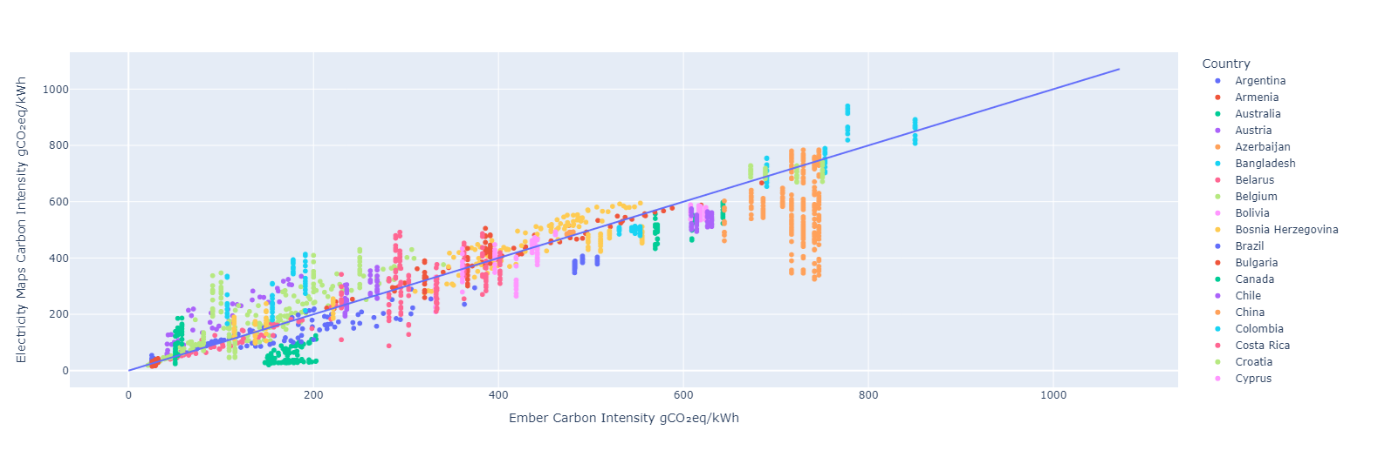

Study
- Present the specific system analyzed.
- Inventory of resources or components.
- Quantitative data collection process.
- how the thing produced works
- what was produced and how it can be used/useful

Findings
- describe graphs (what can we see in them (remarks) and what they show)
- Intro to findings (lil paragraph) + thesis? (what is to be proven below)
- subsections with each part
- describe terms and methods for each section, use examples to show data types, formats, and calculations
- Tables, graphs, and summary statistics.

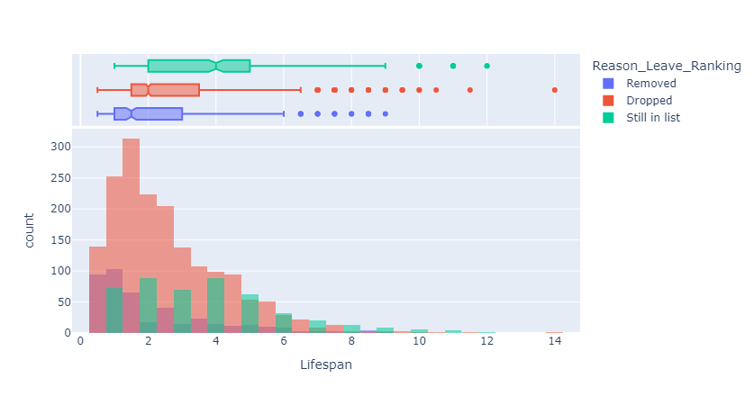
Removed : RMax de le 500eme supercalcul dans la list suivant n’est PAS plus puissant que le supercalcul (Supprimé explicitment)
Dropped : RMax de le 500eme supercalcul dans la list suivant est plus puissant que le supercalcul
Still In List : L’apparance le plus recent est dans le ranking le plus recent
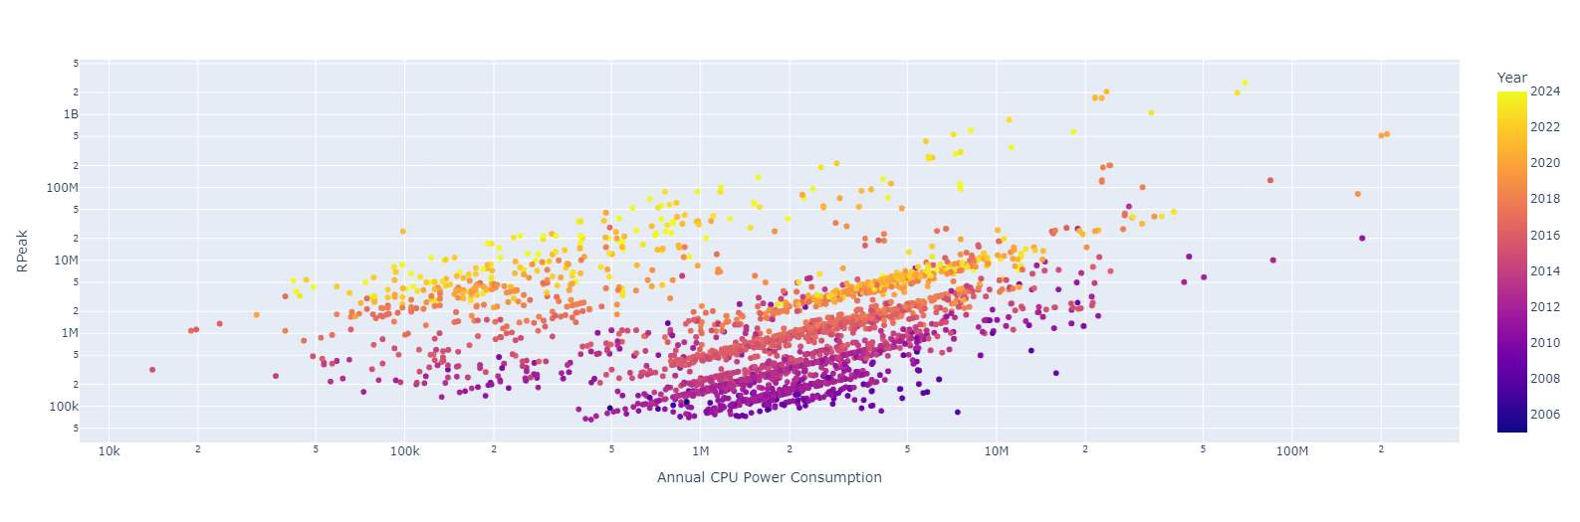
Conclusion//Discussion
- interpret results
-highlight assumptions, biases, uncertainties
- discuss implications and comparisons with literature
- discuss limitations (what is missing or incomplete), how future work can improve reliability & scope
- where to take the project from here, potential action items or recommendations
- recap key takeaways
- link findings back to problem
- skills acquired over period of internship & new perspectives
- In the future:
- incorporate PUE (worldwide average power usage effectiveness)
- More graphs
-
ISSUES
Systems
Entrée/Sortie de TOP500
- dans le ranking avant l’installation
- n’est pas enlevé de la liste (remain listed after being decommissioned or removed)
Cores
- TDP underestimates power draw in some cases **https://www.anandtech.com/show/13544/why-intel-processors-draw-more-power-than-expected-tdp-turbo**
TDP n’est qu’une estimation de la consommation d’énergie
Informations manquantes pour faire des calcul - et hypothèses à faire
- no data on the memory of systems, memory is a factor that has a large impact on energy use as well as abiotic resource depletion (GreenAlgorithims Data)
- 0s as GPU model name when there is indication (1 in Accelerator/co-processor col, but what does that actually mean?) that there may be a GPU included in the system → GPU avec nombre 0 a un nombre des cores > 0
- outliers in the number of cores
Electricity
- Différence importante sur le gaz, à la fois en TWh et sur le fatceur de conversion, ex. 2023:
Ember : 15.3 TWh -> 6.9 mtCO2 (450 gCO2e/kWh)
EM: 13.8 TWh -> 8.2 mtCO2 (594 gCO2e/kWh)
- Difference in gCO2e/kWh between Ember and EM for per-gram methane impact (21g for ember, 34g for EM)
Facteurs d’émission → Difference entre Ember et Electricity Maps
* Quand il n’ya pas de données d’impact, ils utilisent leurs propres méthodes d’estimation
- energy mix of a country varies by the hour (Electricity maps)
- Erreurs nombre de coeurs
- ex. `Voyager-EUS2`, `AMD EPYC 7V12 48C 2.45GHz`, mais les specs le donne plutot pour 64 coeurs
- ex. `AMD EPYC 7302 32C` mais les spec donne 16 coeurs
Glossary//annex
TDP
HPSC
Linpack Benchmark

Bibliography
Electricity Maps (2025). Carbon Intensity Data (Version January 27, 2025). Electricity Maps. https://www.electricitymaps.com

